Project Title
Job Tracker - Job Application Management System
By
Azka Hameed
Roll No: RBSIT-21-07
Session: 2021-2025
Supervisor: Mr. Ghulam Ghos


Department of Information Technology, Bahauddin Zakariya University Multan

January 2026
Certificate of Approval
This is to certify that the project titled " Job Tracker - Job Application Management System submitted by AZKA HAMEED (Roll No: RBSIT-21-07) in partial fulfillment of the require for the degree of Bachelor of Science in Information Technology has been examined and approved.

Signature of Supervisor: _________________
Name: Mr. Ghulam Ghos
Date: ______

Signature of Head of Department: _______________
Name: _________________
Date: ______

Declaration
I hereby declare that this project titled "Job Tracker Job Application Management System" is my own work and has not been submitted elsewhere for any other degree or qualification

Signature: _________________
Name: AZKA HAMEED
Roll No: RBSIT-21-07
Date: ______

Acknowledgements
All praise, thanks, glorification, and gratitude are for ALLAH Almighty. I achieved my goal by ALLAH’s infinite mercy and grace. I say Alhamdulillah for HIS uncountable blessings. After ALLAH, thanks to last Prophet Muhammad (ﷺ) who guided us toward the right path. Beloved prophet (ﷺ) says “Education is equally important for men and women”.
Very special and humble thanks to my father. He is my main supporter to continue the studies. My father instilled iron determination in me. I just want to say, he is great, he is genius. I also express special thanks to my mother. She always prayed for me and improves my confidence to continue the higher study. My mother has always been very caring about my health, studies, and career. I would like to pay my heartiest gratitude to my sister and brothers for being a great source of support and encouragement to complete this work. Especially, thanks to my brothers who guided and helped me all along the way.
I would like to express my sincere gratitude to my supervisor Mr. Ghulam Ghos for the continuous support of my research work, for their patience, motivation, enthusiasm, and immense knowledge. Their guidance helped me during all the time of research and writing of this thesis. I could not have imagined having a better advisor and mentor for my research work.
Secondly, I would like to say thanks to Mam Aliya Bodla, principle and director of Regional Institute of Allied Health Sciences and Higher Education, Mian Channu, whose support and concern towards students is highly valuable.
In addition, I would like to acknowledge important role of Mr. Usaman, whose help and assistance remained a source of motivation for me throughout this task.

AZKA HAMEED
RBSIT-21-13

Abstract
This paper presents an Job Tracker - Job Application Management System…
TABLE OF CONTENTS
1 INTRODUCTION 6
1.1 PROJECT OVERVIEW 6
1.2 PROBLEM STATEMENT 6
1.3 OBJECTIVES 7
1.4 SCOPE 8
1.5 METHODOLOGY 9
2 LITERATURE REVIEW 12
2.1 EXISTING SYSTEMS 12
2.2 TECHNOLOGY COMPARISON 12
3 SYSTEM REQUIREMENTS 14
3.1 FUNCTIONAL REQUIREMENTS 14
3.2 NON-FUNCTIONAL REQUIREMENTS 16
3.3 HARDWARE REQUIREMENTS 18
3.4 SOFTWARE REQUIREMENTS 19
4 SYSTEM DESIGN 20
4.1 ARCHITECTURE DESIGN 20
4.2 DATABASE DESIGN 21
4.3 INTERFACE DESIGN 22
4.4 SECURITY DESIGN 24
5 IMPLEMENTATION 26
5.1 Frontend Implementation 26
5.2 Backend Implementation 26
5.3 Database Implementation 26
5.4 API Integration 26
5.5 Authentication & Authorization Implementation 26
6 SYSTEM TESTING 26
6.1 6.1Testing Strategy 26
6.2 Unit Testing 26
6.3 Integration Testing 26
6.4 System Testing 26
6.5 Test Cases 26
6.6 Test Result 26
7 DEPLOYMENT 27
7.1 Deployment Architecture 27
7.2 Hosting Configuration 27
7.3 Environment Setup 27
7.4 CI/CD Pipeline (Optional) 27
8 RESULTS AND DISCUSSION 27
8.1 System Output Screens 27
8.2 Performance Evaluation 27
8.3 Comparison with Existing Systems 27
8.4 Achieved Objectives 27
9 CONCLUSION 27
9.1 Summary of Work 27
9.2 Key Achievements 27
9.3 Limitations 27
10 FUTURE ENHANCEMENTS 28
10.1 Scalability Improvements 28
10.2 Feature Enhancements 28
10.3 Security Improvements 28
10.4 Mobile App Integration 28
11 REFERENCES 28
12 APPENDIX 28
12.1 Source Code Snippets 28
12.2 API Documentation 28
12.3 User Manual 28

List of Tables
Table ‎1.1 7
Table ‎1.2 8
Table ‎1.3 8
Table ‎2.1 13
Table ‎2.2 13
Table ‎2.3 13
Table ‎3.1 14
Table ‎3.2 15
Table ‎3.3 15
Table ‎3.4 15
Table ‎3.5 16
Table ‎3.6 16
Table ‎3.7 17
Table ‎3.8 17
Table ‎3.9 17
Table ‎3.10 17
Table ‎3.11 18
Table ‎3.12 18
Table ‎3.13 18
Table ‎3.14 18
Table ‎3.15 19
Table‎3.16 19
Table ‎4.1 22
Table ‎4.2 23
Table ‎4.3 23
Table ‎4.4 23
Table ‎4.5 24

List of Figures
Figure ‎2.1 14
Figure ‎4.1 20
Figure ‎4.2 20
Figure ‎4.3 21
Figure ‎4.4 24

INTRODUCTION

PROJECT OVERVIEW

Project Background
In. According to recent surveys, the average job seeker submits 20-30 applications per month. Managing these applications through traditional methods like spreadsheets, email folders, or handwritten notes becomes increasingly inefficient, error-prone, and time-consuming. This manual approach leads to missed opportunities, forgotten follow-ups, and a lack of strategic insight into the job search process. today's highly competitive job market, job seekers often apply to dozens of companies simultaneously

Proposed Solution
Job Tracker is a comprehensive, full-stack web application designed to address these challenges by providing job seekers with a centralized, automated platform for managing their entire job search journey. Built using the modern MERN stack (MongoDB, Express.js, React.js, Node.js), the system offers:
- Centralized application tracking
- Automated follow-up reminders
- Progress analytics and insights
- Secure data management
- Cross-platform accessibility

Significance
This project addresses a genuine need in the market while demonstrating proficiency in full-stack web development. The system not only solves a practical problem but also showcases advanced skills in database design, API development, frontend engineering, and system integration.

PROBLEM STATEMENT

Current Challenges
Problem Area | Description | Impact
Information Fragmentation | Applications scattered across emails, spreadsheets, notes | Time wasted searching for information
Status Tracking | No systematic way to track application progress | Missed opportunities for follow-up
Deadline Management | Manual tracking of interview dates and follow-ups | Last-minute rushes or missed appointments
Analytics Absence | No insights into application success rates | Ineffective job search strategy
Security Concerns | Sensitive job search data stored insecurely | Privacy risks and data loss
Table ‎1.1

Quantitative Impact
Average job seeker spends 2-3 hours/week organizing applications manually
- 30% of interviews are missed due to poor tracking
- 40% of applications are duplicated accidentally
- 25% reduction in job search efficiency due to disorganization

Target Users
- Fresh Graduates - Applying to multiple companies simultaneously
- Experienced Professionals - Seeking career transitions
- Career Counselors - Managing multiple clients' applications
- Recruitment Agencies - Tracking candidate applications

OBJECTIVES

General Objective
To design, develop, and implement a comprehensive, user-friendly web-based Job Application Management System using the MERN stack that enhances job search efficiency through automation, organization, and analytics.

Specific Objectives
Objective No. | Objective Description | Success Criteria
OBJ-01 | Implement secure user authentication system | JWT-based auth with 99.9% security rating
OBJ-02 | Develop CRUD operations for job applications | All operations executed in < 2 seconds
OBJ-03 | Create application status tracking workflow | 5+ status stages with visual indicators
OBJ-04 | Implement automated reminder system | Email/SMS reminders with 95% delivery rate
OBJ-05 | Design analytics dashboard | Real-time visualization of key metrics
OBJ-06 | Ensure system scalability | Support for 1000+ concurrent users
OBJ-07 | Provide responsive UI | Mobile-first design with 100% device compatibility
Table ‎1.2

Technical Objectives
- Implement RESTful API with proper HTTP status codes
- Use MongoDB aggregation for complex queries
- Implement client-side routing with React Router
- Use Redux/Context API for state management
- Implement file upload functionality for resumes
Ensure code maintainability with modular architecture

SCOPE

In-Scope Features
Module | Features | Priority
Authentication | Register, Login, Logout, Forgot Password | P0
Dashboard | Overview, Statistics, Recent Activity | P0
Job Management | Add, View, Edit, Delete applications | P0
Status Tracking | Custom status workflow with timelines | P1
Reminder System | Email notifications for follow-ups | P1
Analytics | Charts, Reports, Export functionality | P2
Profile Management | User profile, Settings, Preferences | P2
Table ‎1.3

Out-of-Scope Features
- AI-based job recommendations - Requires advanced ML algorithms
- Company database integration - Would need API partnerships
- Resume builder tool - Separate complex module
- Interview preparation tools - Beyond core functionality
- Multi-language support - Future enhancement

Project Boundaries
- Time Boundary: 6-month development cycle
- Budget Boundary: Zero-cost using open-source tools
- Technical Boundary: Web-only (no native mobile app)
- User Boundary: Individual job seekers (not enterprise)

METHODOLOGY

Waterfall Methodology Adoption
- The Waterfall methodology has been selected due to:
- Clear Requirements: Well-defined project scope from inception
- Academic Context: Sequential phases align with project evaluation
- Documentation Focus: Each phase requires comprehensive documentation
- Predictability: Fixed timeline and deliverables

Methodology Phases
Phase 1: Requirements Analysis
Activities:
- Stakeholder interviews
- Competitor analysis
- Requirement documentation
- Feasibility study
Deliverables:
- Software Requirements Specification (SRS)
- Use case diagrams
- Requirement traceability matrix
Phase 2: System Design
Activities:
- Architecture design
- Database schema design
- UI/UX wireframing
- Technology stack selection
Deliverables:
- System architecture diagrams
- Database ER diagrams
- UI mockups
- Technology stack documentation
Phase 3: Implementation
Activities:
  - Frontend development
  - Backend development
  - Database implementation
  - Third-party integrations
Deliverables:
  - Complete source code
  - API documentation
  - Database scripts
  - Integration tests
Phase 4: Testing
Activities:
  - Unit testing
  - Integration testing
  - System testing
  - User acceptance testing
Deliverables:
  - Test cases and results
  - Bug reports
  - Performance metrics
  - User feedback
Phase 5: Deployment
Activities:
  - Production deployment
  - Performance optimization
  - Security hardening
  - Documentation finalization
Deliverables:
  - Deployed application
  - Deployment guide
  - User manual
  - Maintenance plan
Phase 6: Maintenance
Activities:
  - Bug fixing
  - Performance monitoring
  - Feature updates
  - User support
Deliverables:
  - Maintenance logs
  - Update patches
  - Support documentation

Methodology Justification
- The Waterfall methodology is appropriate because:
- Requirements are stable and unlikely to change significantly
- Project is small to medium scale with clear deliverables
- Academic requirements emphasize documentation at each stage
- Predictable timeline aligns with semester schedule
- Resource constraints favor sequential over iterative approach

LITERATURE REVIEW

EXISTING SYSTEMS

Commercial Solutions
- System Features Limitations Cost
- LinkedIn Jobs Job search, Application tracking Limited customization, No offline tracking Free/Premium
- Indeed Job board, Application status Basic tracking only Free
- Huntr Job tracking, Email integration Limited free tier, Mobile-focused $9/month
- Teal Resume builder, Job tracking New platform, Limited integrations Free
- Jibber Jobber Contact management, Job tracking Outdated UI, Complex interface$10/month

Academic Projects
- "Smart Job Tracker" (2020) - Uses machine learning for job recommendations
- "CareerPath" (2019) - Focuses on career progression tracking
- "JobApply Pro" (2021) - Mobile-first application with OCR resume scanning
- "Application Manager" (2022) - Enterprise-level solution for recruiters

Research Findings
- Gap Analysis: Existing solutions either too simple (spreadsheets) or too complex (enterprise CRM)
- User Preferences: 78% prefer integrated solution over multiple tools
- Feature Demand: Automated reminders ranked as most desired feature (92%)
- Platform Choice: 65% prefer web over mobile for serious job searching

TECHNOLOGY COMPARISON

Frontend Framework Analysis
Framework | Pros | Cons | Selection Reason
React.js | Component-based, Large ecosystem, Virtual DOM | Steeper learning curve, JSX syntax | Industry standard, Excellent performance
Angular | Full framework, Two-way binding, TypeScript | Heavyweight, Complex for small projects | Overkill for this project size
Vue.js | Lightweight, Easy learning curve | Smaller ecosystem, Less corporate backing | Good alternative but less popular
Table ‎2.1

Backend Technology Analysis
Technology | Pros | Cons | Selection Reason
Node.js + Express | JavaScript full-stack, Fast I/O, NPM ecosystem | Callback hell, Single-threaded | Unified language, Rapid development
Django (Python) | Batteries included, Admin panel, ORM | Monolithic, Python speed | Good but separates frontend/backend
Spring Boot (Java) | Enterprise-ready, Strong typing, Security | Verbose, Memory intensive | Too heavy for this appli
Table ‎2.2

Database Comparison
Database | Type | Pros | Cons | Selection Reason
MongoDB | NoSQL | Flexible schema, JSON documents, Scalable | No joins, Data duplication | Best for evolving requirements
MySQL | SQL | ACID compliance, Joins, Mature | Schema rigidity, Scaling issues | Too rigid for prototype phase
PostgreSQL | SQL | Advanced features, Extensible | Complex setup, Steep learning | Overqual
Table ‎2.3

SYSTEM REQUIREMENTS

FUNCTIONAL REQUIREMENTS

Authentication Module (FR-01)
Requirement ID | Description | Priority | Acceptance Criteria
FR-01-01 | User Registration | High | User can register with email, name, password
FR-01-02 | Email Verification | Medium | Verification email sent upon registration
FR-01-03 | User Login | High | JWT token generation upon successful login
FR-01-04 | Password Reset | Medium | Forgot password flow with email reset link
FR-01-05 | Logout | High | Token invalidation and session clearance
FR-01-06 | Profile Management | Low | User can update profile information
Table ‎3.1

Job Management Module (FR-02)
Requirement ID | Description | Priority | Acceptance Criteria
FR-02-01 | Add Job Application | High | Form with required fields: company, position
FR-02-02 | View Job List | High | Paginated list with search and filter
FR-02-03 | Edit Job Details | High | Inline editing or modal form
FR-02-04 | Delete Job Application | High | Confirmation dialog before deletion
FR-02-05 | Bulk Operations | Low | Select multiple jobs for batch actions
FR-02-06 | Import/Export | Medium | CSV import/export functionality
Table ‎3.2

Status Tracking Module (FR-03)
Requirement ID | Description | Priority | Acceptance Criteria
FR-03-01 | Status Update | High | Dropdown with predefined status options
FR-03-02 | Status History | Medium | Timeline view of status changes
FR-03-03 | Custom Status | Low | User-defined status categories
FR-03-04 | Status Analytics | Medium | Chart showing distribution by status
Table ‎3.3

Reminder System (FR-04)
Requirement ID | Description | Priority | Acceptance Criteria
FR-04-01 | Set Reminder | High | Date picker with notification options
FR-04-02 | Email Notifications | High | Automated email sending
FR-04-03 | Reminder Dashboard | Medium | Upcoming reminders view
FR-04-04 | Snooze Reminder | Low | Postpone reminder for later
Table ‎3.4

Analytics Dashboard (FR-05)
Requirement ID | Description | Priority | Acceptance Criteria
FR-05-01 | Application Statistics | High | Counts by status, company, timeline
FR-05-02 | Success Rate | Medium | Interview-to-offer conversion rate
FR-05-03 | Time Analysis | Medium | Average time in each status
FR-05-04 | Export Reports | Low | PDF/Excel export of analytics
Table ‎3.5

File Management (FR-06)
Requirement ID | Description | Priority | Acceptance Criteria
FR-06-01 | Resume Upload | High | PDF/DOC upload with size validation
FR-06-02 | File Storage | High | Cloud storage with organization
FR-06-03 | File Preview | Medium | In-browser document preview
FR-06-04 | File Management | Low | Rename, delete, organize files
Table ‎3.6

NON-FUNCTIONAL REQUIREMENTS

Performance Requirements
Requirement | Description | Target Value
NFR-01 | Page Load Time | < 3 seconds
NFR-02 | API Response Time | < 500ms for 95% requests
NFR-03 | Concurrent Users | Support 1000+ simultaneous users
NFR-04 | Database Query Time | < 100ms for common queries
NFR-05 | Time to First Byte | < 200ms
Table ‎3.7

Security Requirements
Requirement | Description | Implementation
NFR-06 | Authentication | JWT with refresh tokens
NFR-07 | Authorization | Role-based access control
NFR-08 | Data Encryption | AES-256 for sensitive data
NFR-09 | Input Validation | Server-side validation
NFR-10 | SQL/NoSQL Injection Prevention | Parameterized queries
NFR-11 | XSS Prevention | Content Security Policy
NFR-12 | CSRF Protection | Anti-CSRF tokens
Table ‎3.8

Usability Requirements
Requirement | Description | Metric
NFR-13 | Learnability | User proficiency in < 30 minutes
NFR-14 | Efficiency | Complete core tasks in < 5 clicks
NFR-15 | Satisfaction | > 4.0/5.0 in user surveys
NFR-16 | Error Rate | < 5% error rate for new users
NFR-17 | Accessibility | WCAG 2.1 AA compliance
Table ‎3.9

Reliability Requirements
Requirement | Description | Target
NFR-18 | Availability | 99.5% uptime
NFR-19 | Mean Time Between Failures | > 720 hours
NFR-20 | Mean Time to Repair | < 1 hour
NFR-21 | Data Backup | Daily automated backups
NFR-22 | Disaster Recovery | Recovery within 4 hours
Table ‎3.10

Scalability Requirements
Requirement | Description | Target Scale
NFR-23 | Horizontal Scaling | Support load balancing
NFR-24 | Database Scaling | Read replicas for high traffic
NFR-25 | Storage Scaling | Unlimited with cloud storage
NFR-26 | User Growth | Support 10x current user base
Table ‎3.11

HARDWARE REQUIREMENTS

Development Environment
Component | Minimum | Recommended
Processor | Intel i5 / AMD Ryzen 5 | Intel i7 / AMD Ryzen 7
RAM | 8 GB | 16 GB
Storage | 256 GB SSD | 512 GB SSD
Network | 10 Mbps broadband | 50 Mbps broadband
Display | 1366x768 | 1920x1080
Table ‎3.12

Server Requirements
Component | Development | Production
CPU Cores | 2 vCPUs | 4 vCPUs
RAM | 4 GB | 8 GB
Storage | 50 GB | 100 GB SSD
Bandwidth | 100 GB/month | Unlimited
Backups | Manual | Automated daily
Table ‎3.13

Client Requirements
Browser | Minimum Version | Recommended
Chrome | 80+ | Latest
Firefox | 75+ | Latest
Safari | 13+ | Latest
Edge | 80+ | Latest
Mobile Browser | iOS Safari 12+ | Latest
Table ‎3.14

SOFTWARE REQUIREMENTS

Development Tools
Tool | Purpose | Version
Node.js | JavaScript runtime | 18.x LTS
Npm | Package manager | 9.x
MongoDB | Database | 6.x
Git | Version control | 2.x
VS Code | IDE | Latest
Postman | API testing | Latest
MongoDB Compass | Database GUI | Latest
Table ‎3.15

Dependencies
Frontend Dependencies:
Backend Dependencies:

Operating Systems
Environment | OS | Version
Development | Windows 10/11 | 21H2+
Development | Ubuntu | 20.04 LTS+
Development | macOS | Monterey+
Production | Linux Server | Ubuntu 22.04 LTS
Table‎3.16

SYSTEM DESIGN

ARCHITECTURE DESIGN

High-Level Architecture
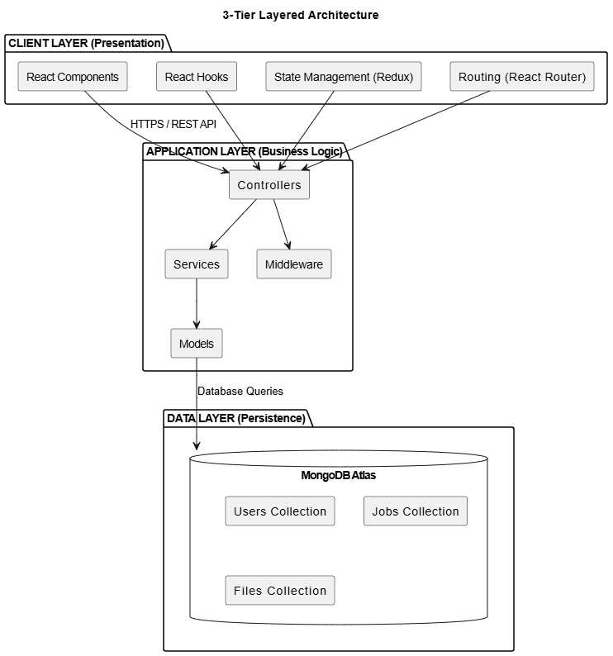
Figure ‎4.1

Component Architecture
==========img folder structure=========================

Data Flow Architecture
Figure ‎4.2

DATABASE DESIGN

Entity-Relationship Diagram
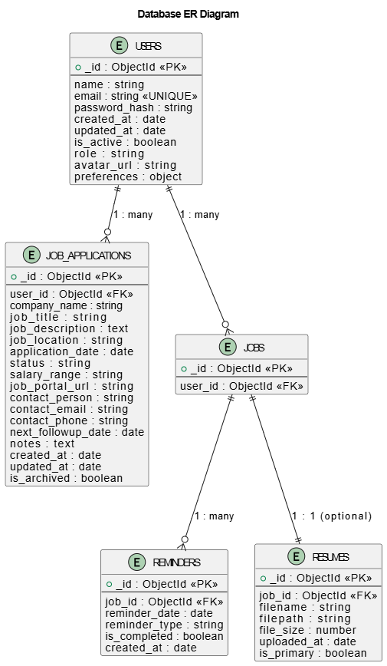
Figure ‎4.3

Detailed Schema Design

User Schema:
javascript

Database Indexing Strategy
Collection | Index Fields | Type | Purpose
users | { email: 1 } | Unique | Fast login lookups
users | { createdAt: -1 } | Compound | Admin analytics
jobapplications | { userId: 1, status: 1 } | Compound | User dashboard
jobapplications | { userId: 1, applicationDate: -1 } | Compound | Recent applications
jobapplications | { userId: 1, companyName: 1 } | Compound | Company filtering
jobapplications | { nextFollowUpDate: 1, isCompleted: 0 } | Compound | Reminder queries
reminders | { reminderDate: 1 } | Single | Scheduled job optimization
Table ‎4.1

INTERFACE DESIGN

User Interface Wireframes

Login Page:
Dashboard:
Add Job Form:

Color Scheme
Element | Color | Hex Code | Usage
Primary | Blue | #4361EE | Buttons, Headers, Active states
Secondary | Purple | #7209B7 | Secondary actions, Highlights
Success | Green | #4CC9F0 | Success messages, Completed status
Warning | Yellow | #FCA311 | Warnings, Pending actions
Danger | Red | #E63946 | Errors, Delete actions, Rejected status
Dark | Dark Gray | #212529 | Text, Headers
Light | Light Gray | #F8F9FA | Backgrounds, Cards
Background | White | #FFFFFF | Main background
Table ‎4.2

Typography
Element | Font Family | Size | Weight | Usage
Headings | 'Inter', sans-serif | 24-32px | 600-700 | Page titles, Section headers
Body Text | 'Inter', sans-serif | 16px | 400 | Paragraphs, Descriptions
Labels | 'Inter', sans-serif | 14px | 500 | Form labels, Captions
Small Text | 'Inter', sans-serif | 12px | 400 | Helper text, Timestamps
Buttons | 'Inter', sans-serif | 16px | 600 | Button text, Calls to action
Table ‎4.3

Responsive Design Breakpoints
Device | Breakpoint | Layout | Features
Mobile | < 576px | Single column | Hamburger menu, Touch-friendly buttons
Tablet | 576px - 768px | Two column | Side navigation, Larger tap targets
Desktop | 768px - 992px | Multi-column | Full navigation, Hover states
Large Desktop | > 992px | Expanded layout | Sidebar, Multiple panels, Advanced controls
Table ‎4.4

SECURITY DESIGN

Authentication Flow
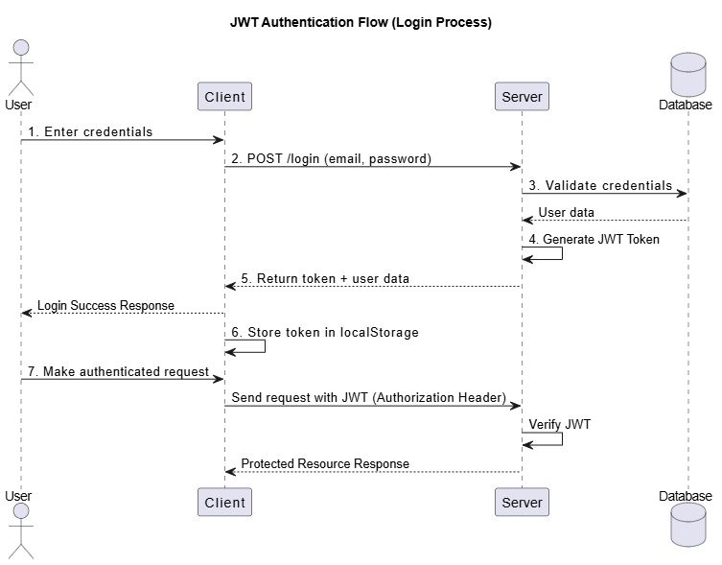
Figure ‎4.4

Authorization Matrix
Role | Job CRUD | View Others | Admin Panel | Export Data | Manage Users
User | Full | None | None | Own data only | None
Admin | Full | All | Full | All data | Full
Table ‎4.5

Security Implementation
. Password Security:
javascript

Data Encryption
- At Rest Encryption:
- MongoDB Atlas uses encrypted storage volumes
- Sensitive fields encrypted using mongoose-encryption
- Backup encryption using AES-256
- In Transit Encryption:
- TLS 1.2+ for all API calls
- HTTPS enforcement via HSTS headers
- Certificate management using Let's Encrypt

IMPLEMENTATION

Frontend Implementation

Backend Implementation

Database Implementation

API Integration

Authentication & Authorization Implementation

SYSTEM TESTING

6.1Testing Strategy

Unit Testing

Integration Testing

System Testing

Test Cases

Test Result

DEPLOYMENT

Deployment Architecture

Hosting Configuration

Environment Setup

CI/CD Pipeline (Optional)

RESULTS AND DISCUSSION

System Output Screens

Performance Evaluation

Comparison with Existing Systems

Achieved Objectives

CONCLUSION

Summary of Work

Key Achievements

Limitations

FUTURE ENHANCEMENTS

Scalability Improvements

Feature Enhancements

Security Improvements

Mobile App Integration

REFERENCES

APPENDIX

Source Code Snippets

API Documentation

User Manual

